002133899

**Program Structures & Algorithms**

**Fall 2021**

**Assignment No. 1**

* **Task 1. m = 91, n = 19, mean distance = 10.662593940278816**
* **Task 2. m= 47, n = 67, mean distance = 5.972008685462649**
* **Task 3. m = 69, n = 31, mean distance = 7.035064995795392**
* **Task 4. m = 10, n = 47, mean distance = 2.513646095425789**
* **Task 5. m = 46, n = 49, mean distance = 5.360369033468101**
* **Task 6. m = 81, n = 27, mean distance = 6.031041833924145**
* **Relationship Conclusion: d = $√n$**
* **Evidence to support the conclusion:**

1. **Output**

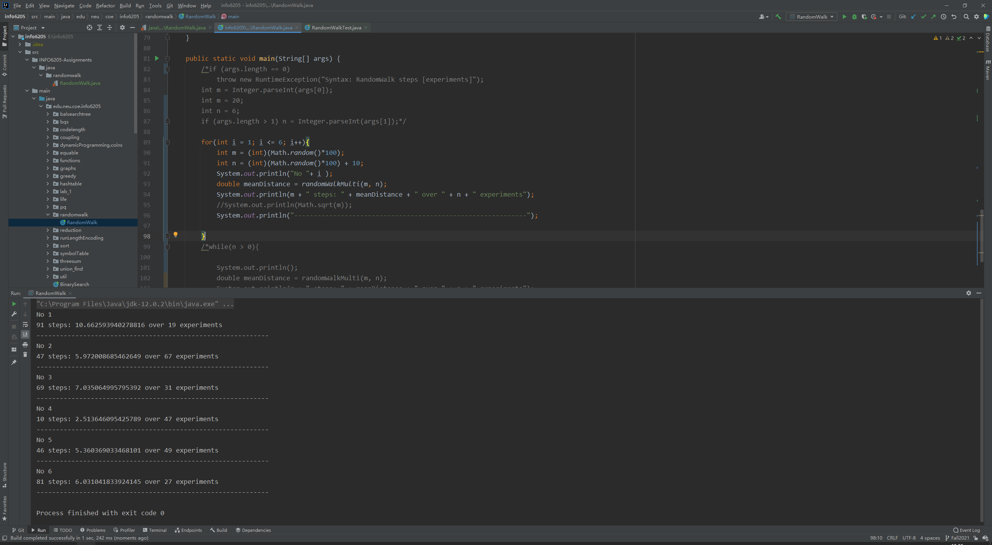

1. **Graphical Representation**

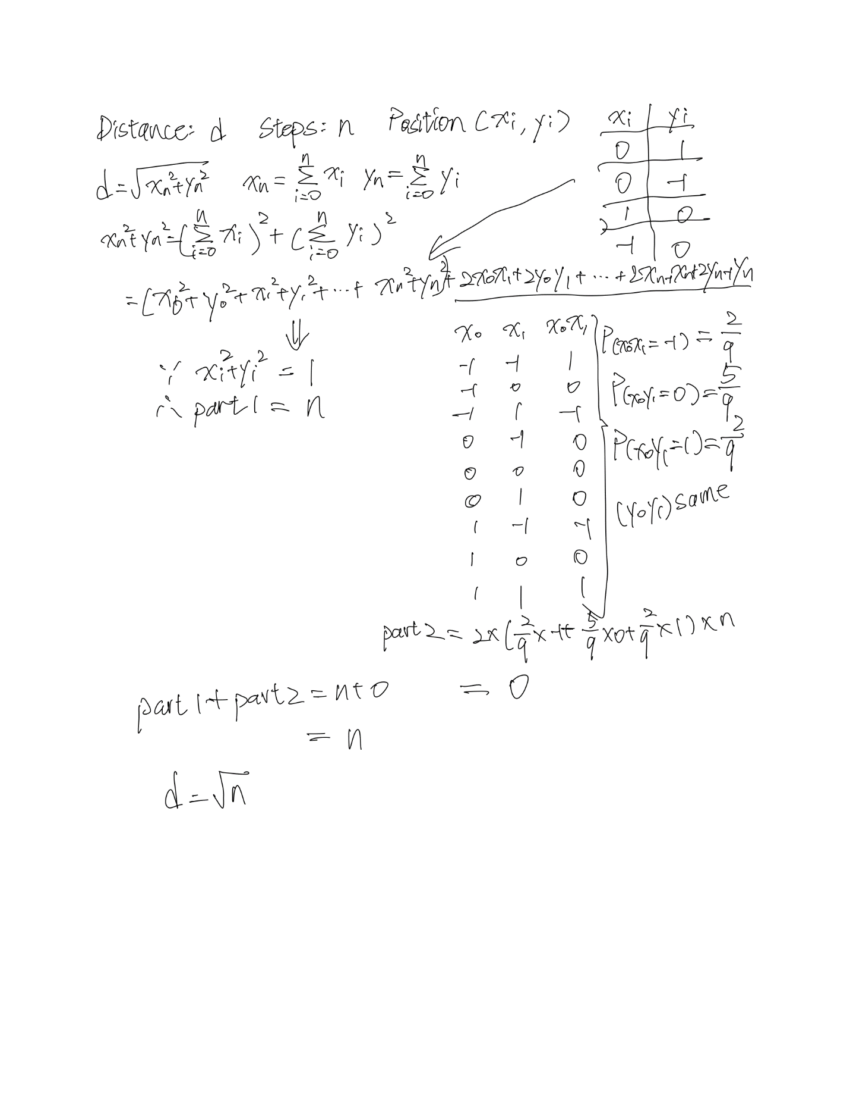

**Unit tests result:**

